Committee Meeting

Agenda

6th November 2018 at 7:30pm
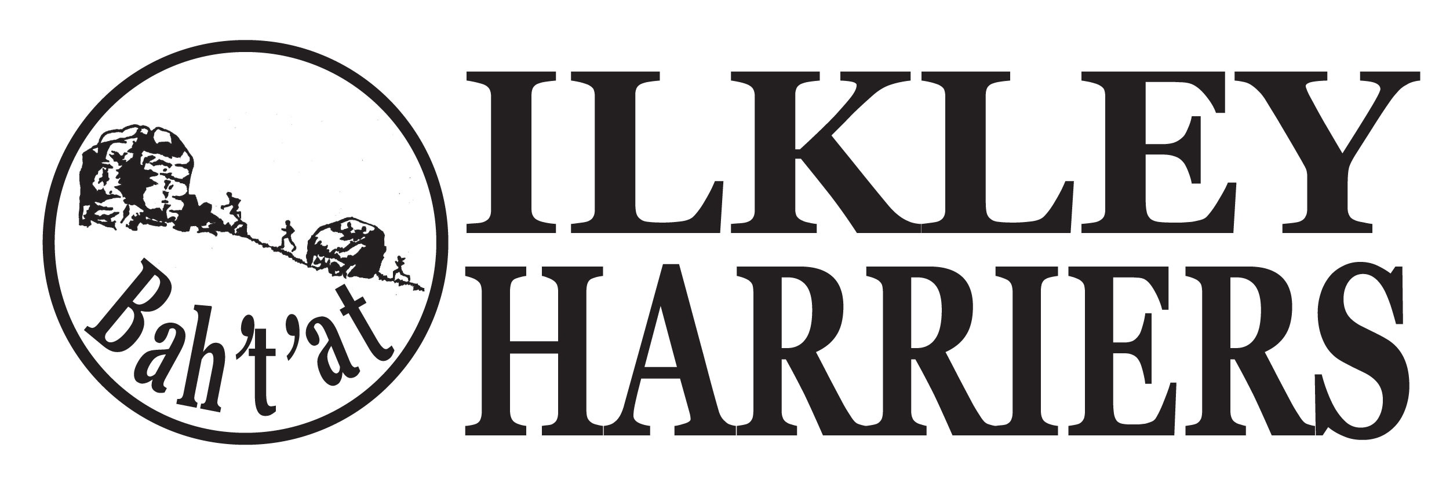
- Apologies

2. Minutes of Meeting 25th September 2018

3. Matters arising

4. Running the Club:

4.1 Nominations for “Outstanding Achievements” of the month for October.

4.2 AGM outcomes and actions, including committee and roles update

4.3 Events: Preparation for Christmas relays, quiz and food. Preparation for annual awards do in January. IMFR 2019. League races for 2019. VLM club places.

4.4 Annual awards decision process. Hall of fame and age records updating

4.5 Membership update on renewals in October.

4.6 Juniors

5. Developing the Club

5.1 Process for updating Development plan

5.2 Junior facilities update.

6. AOB
  - Northern Athletics AGM is 10th November 11.00am in Manchester - can anyone attend?

Next meeting: Agree awards and finalise annual do arrangements. (Tuesday 8th Jan is the very latest possible to get awards inspired in time)

